Shared Mailbox - Outlook

Step by Step

Objective
Add a shared mailbox to the user's Outlook.
- Open Outlook (new) and click File, then open the Settings menu.
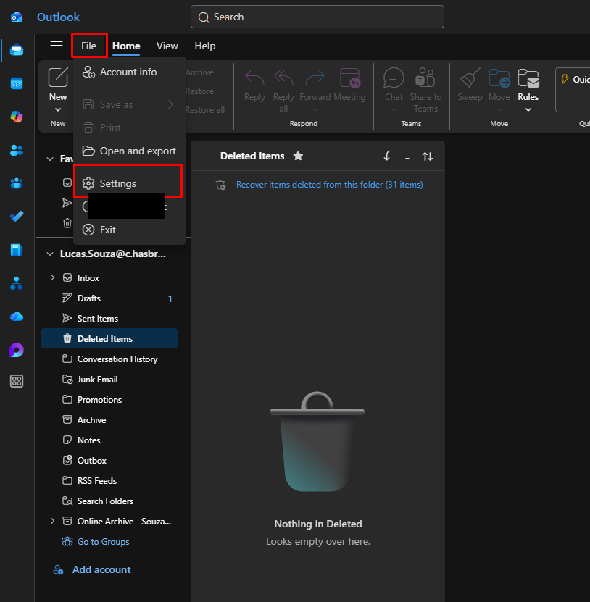
- In the Settings menu, on the left side, click Accounts, then click Shared with me, and then click + Add.
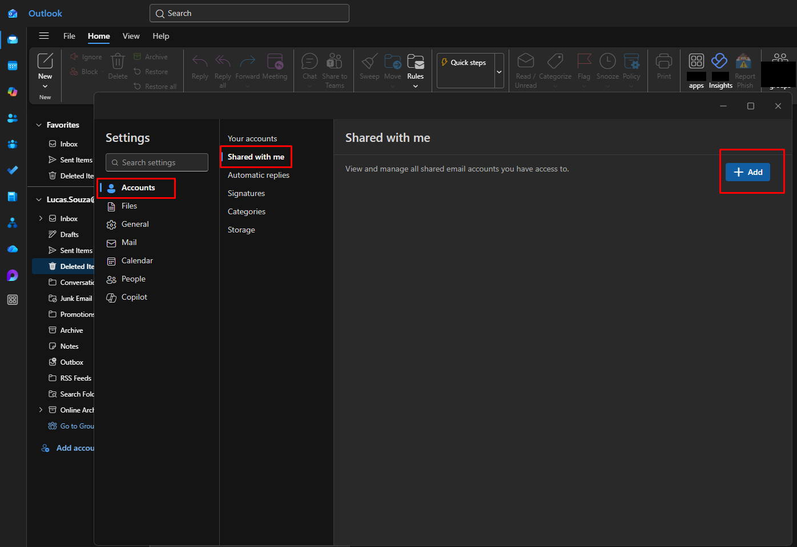
- Enter the shared mailbox address.
NOTE: You or the user must have access permission. How to validate: first, confirm in Shared Mailboxes management (USING THE -PS ACCOUNT) whether the user is authorized. Access the mentioned link, select the mailbox related to the requester, and expand the Members section. If the user is already on the list, proceed. If not, ask the manager whether this can be done (if the manager refuses, STOP, do NOTHING, and INFORM THE USER of the manager's refusal).
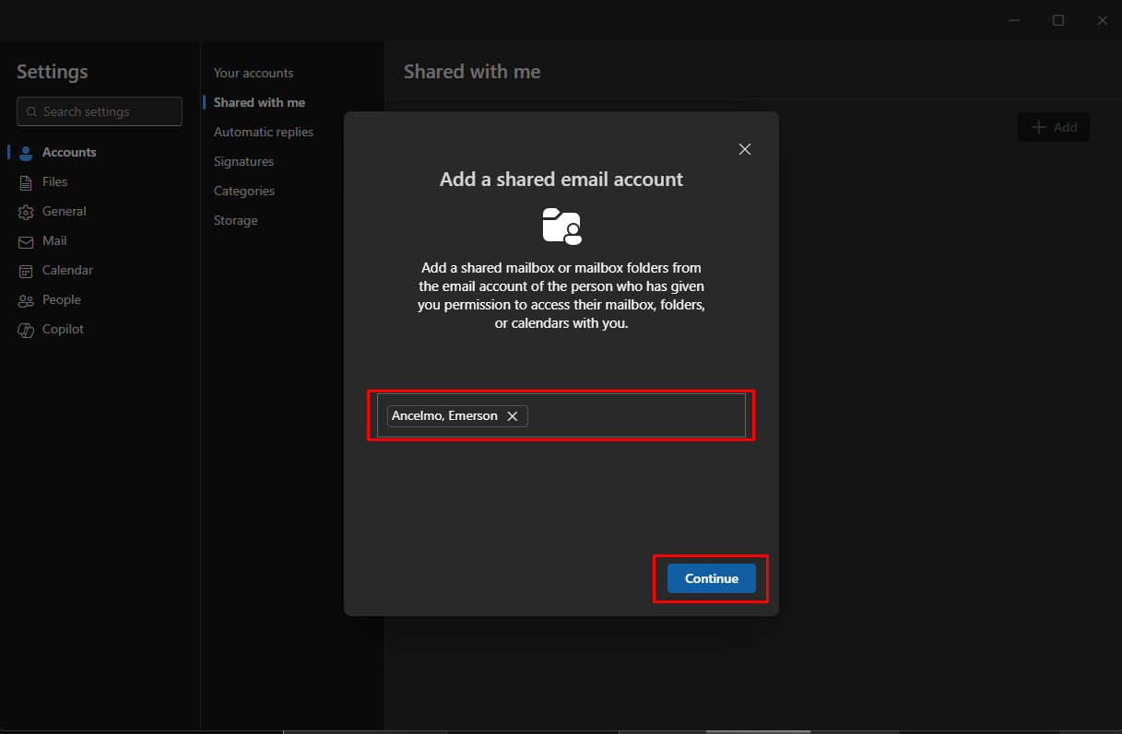

Version History
Author | Version | Date | Description
Lucas Souza | 1.0 | Jun/2026 | Document creation

